Chapter 3, Solution 60

Calculate the power dissipated in each resistor in the circuit in Fig. 3.104.

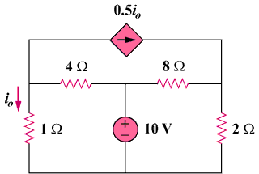

56 V

Figure 3.104
For Prob. 3.60.

Solution

0.5i₀

v₂
–
+

56 V

56 V

2 Ω

8 Ω

4 Ω

1 Ω

v₁

i₀

At node 1, [(v₁–0)/1] + [(v₁–56)/4] + 0.5[(v₁–0)/1] = 0 or 1.75v₁ = 14 or v₁ = 8 V

At node 2, [(v₂–56)/8] – 0.5[8/1] + [(v₂–0)/2] = 0 or 0.625v₂ = 11 or v₂ = 17.6 V

P_{1Ω} = (v₁)²/1 = 64 watts, P_{2Ω} = (v₂)²/2 = 154.88 watts,

P_{4Ω} = (56 – v₁)²/4 = 576 watts, P_{8Ω} = (56 – v₂)²/8 = 1.84.32 watts.

